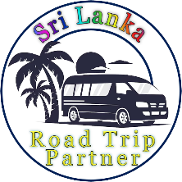

Sri Lanka Road Trip Partner

Explore Sri Lanka with us and create unforgettable memories.

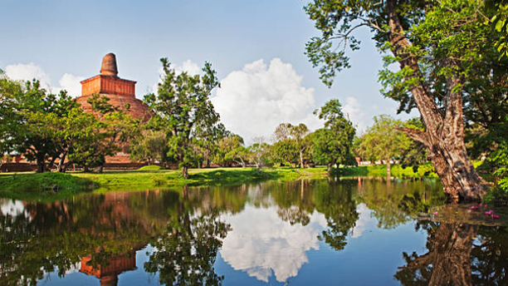
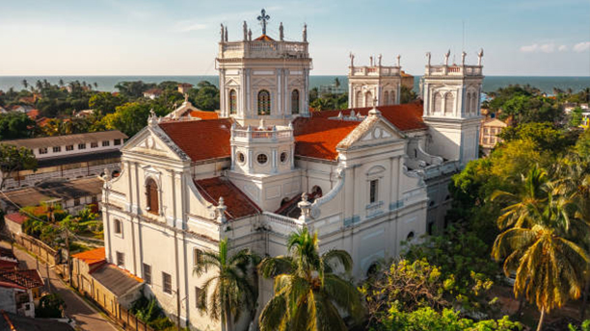

2 Day - Anuradapura
Anuradhapura is one of the ancient capitals of Sri Lanka, renowned for its well-preserved ruins of ancient Sri Lankan civilization.
Things to Do:
- Visit Sri Maha Bodhi Tree
- Sightseeing The Ancient ruined City
- Visit Isurumuniya Temple
- Go on a Jeep Safari In Wilpattu National Park
- Visit Mihintale
- Visit Avukana Buddha Statue

1 Day - Negombo
Negombo is a vibrant coastal city known for its sandy beaches, bustling fish markets, and colonial architecture.
Things to Do:
- Visit Negombo Beach
- Dutch Canal Boat Ride
- Visit Negombo Fish Market (Lellama)
- Explore Negombo Night Market
- Visit St. Mary's Church
- Visit Angurukaramulla Temple

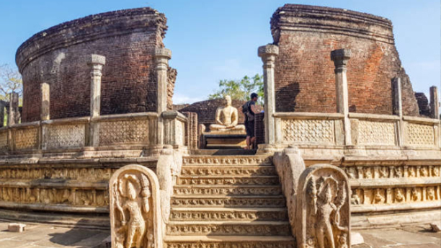
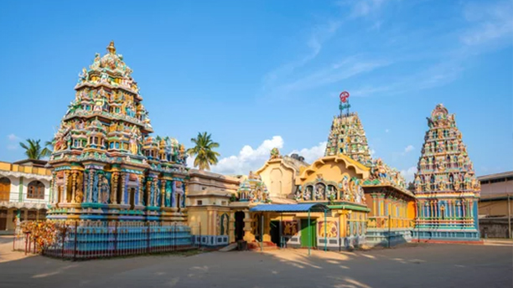


3 Day - Polonnaruwa
Polonnaruwa, another ancient capital, is famous for its archaeological sites showcasing the grandeur of medieval Sri Lankan architecture.
Things to Do:
- Explore the Ancient City of Polonnaruwa
- See the Gal Vihara Buddha Statues
- Visit the Royal Palace of King Parakramabahu
- Explore the Quadrangle (Sacred Complex)
- Discover the Parakrama Samudra (Sea of Parakrama)
- Visit the Archaeological Museum
- Go on a Wildlife Safari at Minneriya or Kaudulla National Park

4 Day - Trincomalee
Trincomalee is a port city known for its natural harbor, beautiful beaches, and the historic Koneswaram Temple.
Things to Do:
- Relax at Nilaveli Beach
- Visit Pigeon Island National Park
- Explore Fort Frederick
- Visit Koneswaram Temple
- Spot Blue Whales & Dolphins
- Swim at Marble Beach
- Explore the Hot Water Springs at Kanniya
- Watch the Sunset at Dutch Bay

5,6 Day - Sigiriya
Sigiriya, also known as Lion Rock, is an ancient rock fortress and palace ruin, offering panoramic views and intricate frescoes.
Things to Do:
- Climb Sigiriya Rock Fortress
- Climb Pidurangala Rock
- Visit Dambulla Cave Temple
- Go on a Village Safari
- Go on a jeep Safari on Minneriya / Kaudulla National Park
- Ayurvedic massage treatments

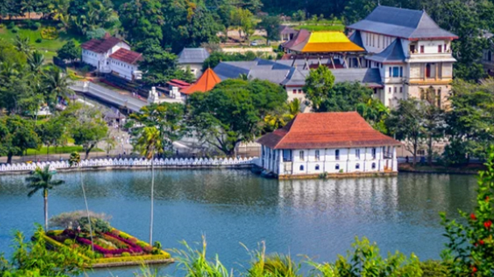
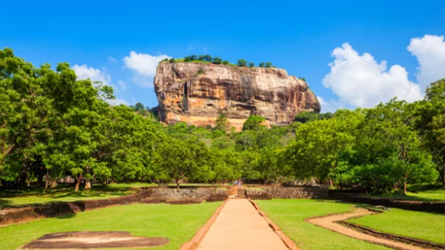

7 Day - Kandy
Kandy is a cultural hub, home to the Temple of the Sacred Tooth Relic and the picturesque Kandy Lake.
Things to Do:
- Visit Temple of the Tooth Relic
- Visit Peradeniya Botanical Gardens
- Watch Kandyan Cultural Dance Show
- Visit Ambuluwawa Tower
- Visit Herbal Spice Gardens

8,9 Day - Ella
Ella is a small town surrounded by lush tea plantations, offering scenic views, hiking trails, and attractions like the Nine Arches Bridge.
Things to Do:
- Hike to Little Adam's Peak
- Visit Nine Arches Bridge
- Take the Train Ride
- Explore Ravana Falls
- Hike to Ella Rock
- Go Zip-lining at Flying Ravana
- Enjoy Night-lift in Ella

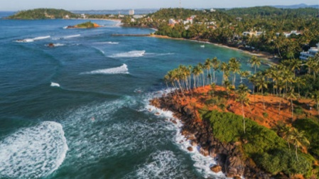
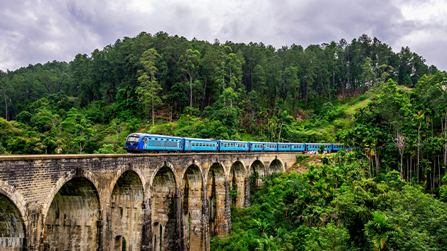

10 Day - Mirissa
Mirissa is famed for its stunning beaches and as a prime spot for whale watching.
Things to Do:
- Go Whale Watching
- Relax at Mirissa Beach
- Climb to Coconut Tree Hill
- Surfing at Weligama Beach
- Visit Secret Beach (Hidden Gem)
- Explore Parrot Rock
- Take a Catamaran Sailing Tour

11 Day - Benthota
Bentota is a resort town known for its expansive beaches, water sports, and the serene Bentota River.
Things to Do:
- Relax at Bentota Beach
- Go on a Boat Safari in Madu River
- Do Water Sports at Bentota River
- Visit Kande Viharaya
- Visit Kosgoda Turtle Hatchery
- Do Snorkeling & Diving
- Do River Kayaking

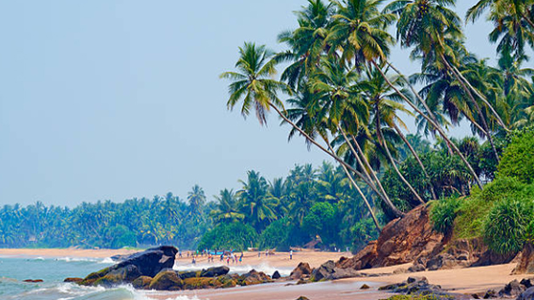

12 Day - Colombo
Colombo is the bustling commercial capital of Sri Lanka, offering a mix of modern urban life and colonial charm.
Things to Do:
- Visit Gangaramaya Temple
- Visit the Red Mosque (Jami Ul-Alfar Mosque)
- Visit Lotus Tower
- Explore the Colombo National Museum
- Visit the Pettah Market
- Explore Dutch Hospital Shopping Precinct
- Experience Colombo's Nightlife
- Walk Along Galle Face Green

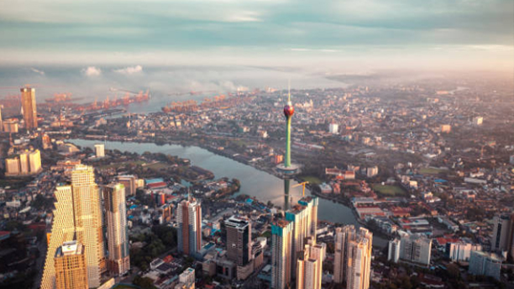

Sri Lanka Road Trip Partner

Package 1
(12 Days / 11 Nights )

We offer our own well-planned travel packages, and we welcome you to customize your own experience as well.

Have a Question?

Call Or WhatsApp :- + 94 77 19 53 880
Email :- malindutissera@gmail.com

Let's turn your travel dreams into reality one incredible adventure at a time!

